***PAAREES PERFUMES***

***Christian Diors***

***FOR WOMEN***

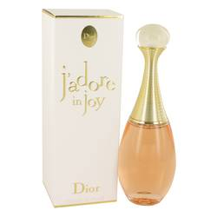

# *Jadore In JoY*

***Description:***

Jadore In Joy by Christian Dior Perfume. Salt is the singular top note that givesJadore in Joy perfume an unusual twist. In contrast with white floral heart notes of tuberose, neroli, ylang ylang and jasmine sambac, the salt gives the fragrance a slightly savory character. The base note of juicy peach binds together the sweet and savory notes and provides a fruity finish. Designed to celebrate joy, fun and love of life in the wearer and her many admirers, the perfume is often described as a salty, white floral fragrance. Appropriate for joyful women of all ages, the perfume is suitable for formal and informal occasions. Spray it on and experience joy.  
  
Released in 2017, the perfume is part of a collection from French fashion designer Christian Dior. In-house perfumer Francois Demachy is the nose behind the fragrance. A native of Cannes, France, he has created many fragrances for men and women for the world-famous brand.